NAME:J.Mohamed Aseem
Date:24/07/2026

SIMATS ENGINEERING
ASSESSMENT TOOL 2

COURSE NAME: Artificial Intelligence COURSE CODE: CSA17

COURSE OUTCOME COVERED

CO1: Apply AI basics such as intelligent agents and uninformed search methods to solve problems effectively.( BL3)

Assessment Tool Weightage: 20%

QUESTIONS: 3 Duration : 45 Minutes Total Marks:30

Annexure A

Constraint-Based Problem Solving

Code of Conduct:

I J.Mohamed Aseem(192511258) (Name / Reg No) certify that this submission is my original work and that I have adhered to the guidelines specified for this assessment.
I understand that any violation of academic integrity rules will result in disciplinary action.



Signature of the student:

Annexure A

Constraint-Based Problem Solving

- A hospital needs to assign 3 doctors (D1, D2, D3) to 3 shifts (Morning, Afternoon, Night) such that:
Constraints:
- D1 cannot work Night shift
- D2 must work before D3 (Morning < Afternoon < Night)
- Only one doctor per shift
- D3 cannot work Morning
- All doctors must be assigned exactly one shift
Apply Backtracking Search to find a valid assignment with all intermediate steps and constraint checks. State the final valid schedule
- A robot operates in a grid environment (5×5). It must move from Start (S) to Goal (G). Obstacles block certain paths.

Constraints:
- Movement allowed: Up, Down, Left, Right
- Cost of each move = 1
- Cannot pass through obstacles
Using above constraints and BFS Search Algorithm Show step-by-step node expansion and priority queue updates and determine the optimal path and cost.

- An autonomous rescue robot is deployed in a disaster-affected building to locate and rescue survivors. The robot operates in a partially observable environment where some paths are blocked, and it must make decisions with limited information.
The building is represented as a grid of rooms. The robot starts at position S and must reach a survivor located at G.

Constraints:
- The robot can move up, down, left, right
- Some cells are blocked (obstacles) and cannot be traversed
- The robot has limited sensing capability (can only observe adjacent cells)
- Each movement has a cost of 1, but entering risky zones has an additional cost of 2
- The robot must minimize total cost while ensuring safe navigation
- The robot must update its knowledge dynamically (online search scenario)

Tasks:
a) Analyze all the given constraints and explain how they affect the robot’s decision-making process.
b) Develop a solution approach using an appropriate search strategy (e.g., Uniform Cost Search / Online Search Agent). Clearly explain the steps involved.
c) Demonstrate how the robot applies AI concepts such as:
- Intelligent agents
- Rationality
- Environment type
d) Justify why your chosen approach is the most suitable for solving this problem under the given constraints.

RUBRICS FOR CALCULATION:

Criteria | Weightage | Level 4 (Exemplary) | Level 3 (Proficient) | Level 2 (Developing) | Level 1 (Beginning)
Problem Understanding | 25% | Clearly defines the problem and identifies all relevant constraints accurately | Identifies most constraints with minor gaps | Partial understanding; misses key constraints | Fails to identify constraints correctly
Constraint Analysis | 25% | Analyzes constraints effectively and prioritizes them logically | Provides reasonable analysis with some prioritization | Limited analysis; weak prioritization | No meaningful analysis or prioritization
Solution Development | 25% | Develops optimal and feasible solutions satisfying all constraints | Develops workable solutions with minor limitations | Solutions partially satisfy constraints | Solutions do not meet constraints
Application of Concepts | 15% | Effectively applies appropriate concepts, methods, or tools | Applies concepts with minor errors | Limited application; requires guidance | Unable to apply relevant concepts
Justification | 10% | Provides strong justification for decisions with logical reasoning | Provides justification with some clarity | Weak or unclear justification | No justification provided

ANSWERS

1-Constraint-Based Problem Solving (Backtracking Search)

Problem Formulation:

- Variables: $D1, D2, D3$ (Doctors)
- Domains: $\{M, A, N\}$ where $M = \text{Morning}$, $A = \text{Afternoon}$, $N = \text{Night}$
- Constraints:
  - $D1 \neq N$
  - $D3 \neq M$
  - $D2 < D3$ (Time order: $M < A < N$)
  - All-Different: $D1 \neq D2$, $D2 \neq D3$, $D1 \neq D3$ (One doctor per shift, all assigned)

Detailed Intermediate Steps & Constraint Checks:

- Step 1: Assign Doctor 1 ($D1$)
  - Try $D1 = M$.
  - Constraint Check: $D1 \neq N \implies$ Passed.
- Step 2: Assign Doctor 2 ($D2$)
  - Option 2a: Try $D2 = M$.
    - Constraint Check: $D1 \neq D2$ (All-Different) $\implies M = M \implies$ Failed.
  - Option 2b: Try $D2 = A$.
    - Constraint Check: $D1 \neq D2 \implies M \neq A \implies$ Passed.
- Step 3: Assign Doctor 3 ($D3$)
  - Option 3a: Try $D3 = M$.
    - Constraint Check: $D3 \neq M \implies$ Failed.
  - Option 3b: Try $D3 = A$.
    - Constraint Check: $D2 \neq D3 \implies A = A \implies$ Failed.
  - Option 3c: Try $D3 = N$.
    - Constraint Check:
      - $D3 \neq M \implies N \neq M \implies$ Passed.
      - $D1 \neq D3 \implies M \neq N \implies$ Passed.
      - $D2 \neq D3 \implies A \neq N \implies$ Passed.
      - $D2 < D3 \implies A < N \implies$ Passed.

Final Valid Schedule:
- Doctor 1 (D1): Morning Shift ($M$)
- Doctor 2 (D2): Afternoon Shift ($A$)
- Doctor 3 (D3): Night Shift ($N$)

1. Overview of the State-Space Tree
- Tree Representation: The diagram illustrates a state-space tree that visually traces the step-by-step decision-making process of a Backtracking Search Algorithm.
- Start Node: The search originates at the root node (Start node), representing the initial unassigned state before making any choices.

2. Step-by-Step Traversal Breakdown
- Path 1 — Exploring Branch A ($\text{Start} \rightarrow \mathbf{A}$):
  - The algorithm makes an initial assignment, moving to node A.
  - From A, it first explores node B:
    - Node B hits a Dead end (violates constraints or leads to an invalid state).
    - Backtrack Step: The algorithm abandons B and returns to parent node A.
  - From A, it next attempts node C:
    - Node C also hits a Dead end.
    - Backtrack Step: Since all branches under A have failed, the algorithm backtracks all the way back to the Start node.
- Path 2 — Exploring Branch D ($\text{Start} \rightarrow \mathbf{D}$):
  - The search resets to the root and moves to node D.
  - From D, it first explores node E:
    - Node E hits a Dead end.
    - Backtrack Step: The algorithm abandons E and returns to parent node D.
  - From D, it then branches to node F:
    - Node F leads to a temporary Dead end path on one branch, forcing a backtrack back to F.
  - From F, it explores its remaining child node G:
    - Node G is identified as a Success node (a complete and valid assignment meeting all constraints).

3. Core Backtracking Concepts Illustrated
- Depth-First Search (DFS) Strategy: The algorithm explores as far down a path as possible (e.g., $\text{Start} \rightarrow \text{A} \rightarrow \text{B}$) before moving laterally or backtracking.
- Pruning / Early Termination: Whenever a node reaches a "Dead end", further exploration along that path is stopped immediately to save computational time.
- Reversibility (Un-doing Choices): Backtracking requires undoing previous variable assignments (moving back up from child to parent) to try alternate branches.

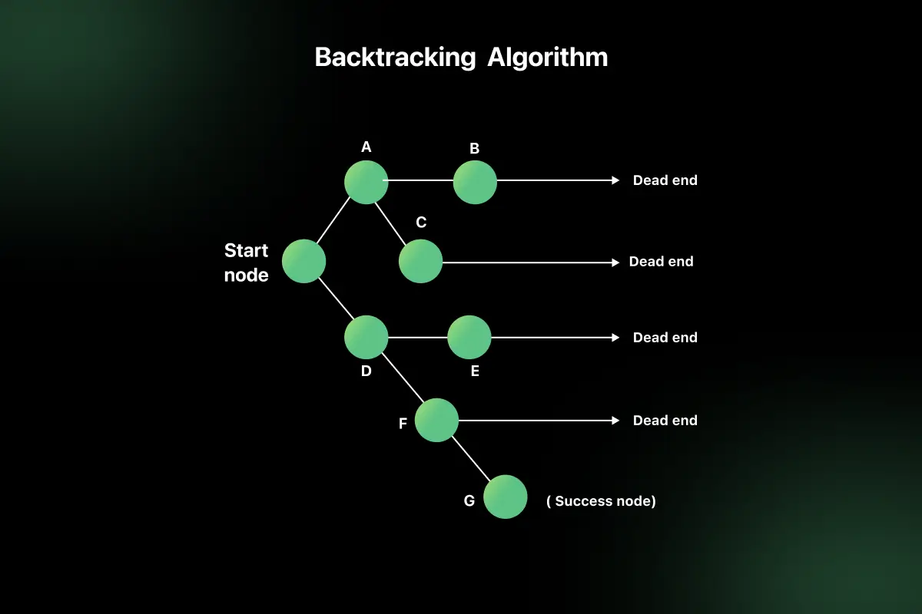

2-Grid Navigation using Breadth-First Search (BFS):

Grid Layout Assumptions:
- Grid Size: $5 \times 5$ grid with coordinates $(r, c)$ where $r \in [1, 5]$ and $c \in [1, 5]$.
- Start (S): $(1, 1)$
- Goal (G): $(3, 3)$
- Obstacles (O): $(1, 2)$ and $(2, 2)$
- Cost: $1$ per step (Up, Down, Left, Right).

Grid Environment Representation (Diagram)

Col 1 Col 2 Col 3 Col 4 Col 5
+--------+--------+--------+--------+--------+
Row 1| S | O | | | |
+--------+--------+--------+--------+--------+
Row 2| | O | | | |
+--------+--------+--------+--------+--------+
Row 3| | | G | | |
+--------+--------+--------+--------+--------+
Row 4| | | | | |
+--------+--------+--------+--------+--------+
Row 5| | | | | |
+--------+--------+--------+--------+--------+

Legend:
S = Start (1,1)
G = Goal (3,3)
O = Obstacle

BFS Execution Steps and Priority/FIFO Queue Updates:

- Step 1:
  - Expand Node: $(1, 1)$
  - Generated Neighbors: $(2, 1)$ [Down], $(1, 2)$ [Right - Obstacle, Skip]
  - Queue (FIFO): [(2, 1)]
- Step 2:
  - Expand Node: $(2, 1)$
  - Generated Neighbors: $(3, 1)$ [Down], $(2, 2)$ [Right - Obstacle, Skip]
  - Queue (FIFO): [(3, 1)]
- Step 3:
  - Expand Node: $(3, 1)$
  - Generated Neighbors: $(4, 1)$ [Down], $(3, 2)$ [Right]
  - Queue (FIFO): [(4, 1), (3, 2)]
- Step 4:
  - Expand Node: $(4, 1)$
  - Generated Neighbors: $(5, 1)$ [Down], $(4, 2)$ [Right]
  - Queue (FIFO): [(3, 2), (5, 1), (4, 2)]
- Step 5:
  - Expand Node: $(3, 2)$
  - Generated Neighbors: $(3, 3)$ [Right - Goal Found!], $(4, 2)$ [Down], $(2, 2)$ [Up - Obstacle, Skip]
  - Queue (FIFO): [(5, 1), (4, 2), (3, 3), (4, 2)]

Optimal Path Diagram and Summary:

Col 1 Col 2 Col 3
Row 1 [ S ] --> O .
|
Row 2 [v] O .
|
Row 3 [v] --> [v] --> [ G ]

Path: (1,1) -> (2,1) -> (3,1) -> (3,2) -> (3,3)

      - Optimal Path: $(1,1) \rightarrow (2,1) \rightarrow (3,1) \rightarrow (3,2) \rightarrow (3,3)$
      - Optimal Path Cost: $4$ units (4 transitions)
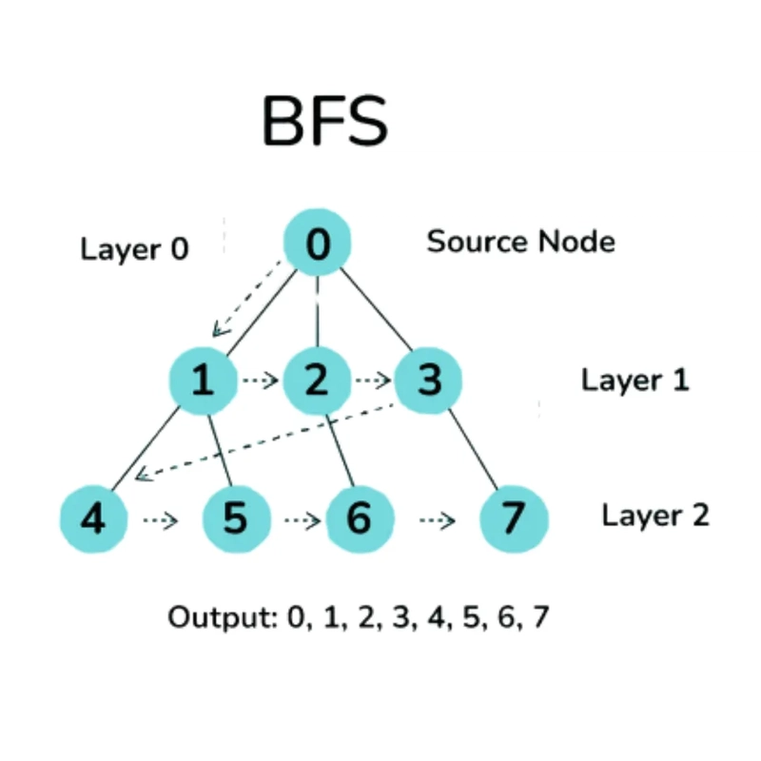

Structure of the Graph:
- Source Node (Root): 0
- Layer 0: Node 0
- Layer 1: Nodes 1, 2, 3
- Layer 2: Nodes 4, 5, 6, 7
The layers represent the distance (number of edges) from the source node.

Step-by-Step Traversal
- Start at Node 0
  - Visit 0.
  - Add its neighbors (1, 2, 3) to the queue.
- Visit Node 1
  - Visit 1.
  - Add its unvisited neighbors (4, 5).
- Visit Node 2
  - Visit 2.
  - Add its unvisited neighbor (6).
- Visit Node 3
  - Visit 3.
  - Add its unvisited neighbor (7).
- Visit Remaining Nodes
  - Visit 4
  - Visit 5
  - Visit 6
  - Visit 7

BFS Traversal Order
0 → 1 → 2 → 3 → 4 → 5 → 6 → 7
This matches the Output shown in the image:
Output: 0, 1, 2, 3, 4, 5, 6, 7

Queue Operation
BFS uses a Queue (FIFO – First In, First Out).
Step | Queue | Visited
Start | 0 | -
Visit 0 | 1,2,3 | 0
Visit 1 | 2,3,4,5 | 0,1
Visit 2 | 3,4,5,6 | 0,1,2
Visit 3 | 4,5,6,7 | 0,1,2,3
Visit 4 | 5,6,7 | 0,1,2,3,4
Visit 5 | 6,7 | 0,1,2,3,4,5
Visit 6 | 7 | 0,1,2,3,4,5,6
Visit 7 | Empty | 0,1,2,3,4,5,6,7

Meaning of the Dashed Arrows
The dashed arrows indicate the order in which BFS moves from one node to the next while processing the queue. They do not represent actual edges in the graph; they simply show the traversal sequence.

Time and Space Complexity
- Time Complexity: O(V + E)
  - V = Number of vertices (nodes)
  - E = Number of edges
- Space Complexity: O(V)
  - Because the queue and visited array can store up to all vertices.

Applications of BFS:
- Finding the shortest path in an unweighted graph.
- Network routing.
- Web crawling by search engines.
- Social network analysis.
- Level-order traversal of binary trees.
- Finding connected components in graphs.
Key Point: BFS visits all nodes at the current level before moving to the next level, which is why the traversal order is 0 → 1 → 2 → 3 → 4 → 5 → 6 →

3- Autonomous Rescue Robot in Partially Observable Environment

Task a: Analysis of Constraints on Decision-Making
- Partial Observability (Local Sensing): The agent cannot see the whole grid at once. It must explore locally and dynamically build/update its internal map.

- Blocked Paths / Obstacles: Prevents direct spatial traversal, forcing the agent to backtrack or reroute dynamically when hitting dead ends.
- Variable Step Costs (Normal = 1, Risky = 3): Standard cost is 1, but risky zones add +2 (Total = 3). The decision-making agent must balance distance against risk cost using cost-aware path planning algorithms.
- Online Search Requirement: Decisions must be interleaved with execution—planning happens as new information is uncovered during navigation.

Task b: Solution Approach (Online Search / Dynamic Uniform Cost Search)

Algorithm Steps
Plaintext
+----------------------+
| Start at Node S |
+----------------------+
|
v
+----------------------+
| Sense Adjacent Cells |
+----------------------+
|
v
+----------------------+
| Update Map & Costs |
| (Normal=1, Risky=3) |
+----------------------+
|
v
+----------------------+
| Select Lowest Cost |
| Step via Priority Q |
+----------------------+
|
v
+----------------------+
| Execute Step Move |
+----------------------+
|
/--------------------\
/ Is Goal Reached? \
\ /
\--------------------/
| |
YES NO
| |
v +---> (Repeat Sensing Step)
+-------------------+
| Goal Reached Stop |
+-------------------+
- Initialize: Maintain a local map estimate, dynamic cost table, and a Priority Queue ordered by path cost g(n).
- Perceive: Observe neighboring cells (Up, Down, Left, Right). Identify obstacles and risky cells.
- Update Map: Assign step cost c=1 for normal path, c=3 for risky path (1+2).
- Select Action: Use Uniform Cost Search (UCS) logic to pick the neighbor with the minimum path cost g(n)=g(current)+c(step).
- Execute and Repeat: Move to the selected state, evaluate if Goal G is reached, and update knowledge dynamically until arrival.

Task c: Demonstration of AI Concepts
Plaintext
+-----------------------------------------------------------------------+
| INTELLIGENT AGENT |
| |
| +---------------+ Perceive Neighbors +------------------+ |
| | Environment | -----------------------> | Sensors | |
| | (Disaster Grid| +------------------+ |
| | Risky Zones) | | |
| | | v |
| | | +------------------+ |
| | | | State/Map Knowledge| |
| | | +------------------+ |
| | | | |
| | | v |
| | | +------------------+ |
| | | | Decision Engine | |
| | | | (Rationality / | |
| | | | UCS Search) | |
| | | +------------------+ |
| | | | |
| | | v |
| | | Execute Movement +------------------+ |
| | Actuators | <----------------------- | Actuators | |
| +---------------+ +------------------+ |
+-----------------------------------------------------------------------+
- Intelligent Agent: A sensor-actuator system operating via a Percept-to-Action loop. Sensors detect obstacle positions and terrain risk; actuators drive physical spatial shifts.
- Rationality: The agent acts rationally by selecting actions that maximize the expected performance measure (minimizing total movement and risk cost) given its current percept sequence and partial map knowledge.
Environment Properties:
  - Partially Observable: Local perception only.
  - Dynamic / Semi-Dynamic: Information changes as the agent moves and reveals unseen terrain.
  - Sequential: Current navigation choices impact all future options and costs.
  - Deterministic: Robot movements and path cost evaluations are direct and non-probabilistic.
  - Discrete: Structured as distinct grid cells and distinct steps.

Task d: Justification of Solution Approach
- Adaptability to Partial Observability: Traditional offline searches (like standard static A*) fail when the full grid map isn't known beforehand. Online Search allows real-time local updates without requiring complete global visibility at start.
- Cost Optimality with Variable Terrain: Uniform Cost Search (UCS) / Path-Cost Online Search guarantees finding the cost-optimal path when edge costs vary (normal vs. risky terrain), avoiding path choices that lead to high cumulative penalties.
- Safety & Efficiency: Interleaving exploration with dynamic priority expansion prevents unnecessary entry into high-risk areas while guaranteeing safe rescue navigation.

